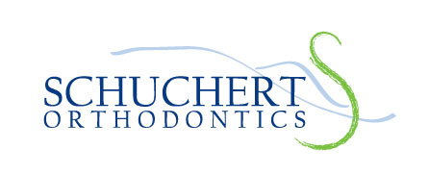
Dr. Joseph R. Schuchert Background & Bio

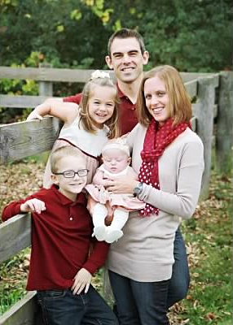
Dr. Joe’s vision for Schuchert Orthodontics starts with patient-centered care. His passion for orthodontics, combined with his love of the region and its people are at the heart of this growing business. When asked about this passion, Dr. Joe explains,
“Orthodontics is a very special profession. Not only does it allow me to improve the quality of life of people each day, but orthodontics allows me to be a part of the lasting memories of patients and a witness to their personal growth and maturation. I learn so much from this interaction with patients and families that the orthodontic care itself becomes a means for me to experience and learn about other people, and hopefully they experience the same working with me.”
Dr. Joe is a native of Pittsburgh, PA and received his undergraduate, dental, and orthodontic degrees all from the University of Pittsburgh. He met his wife Megan there, while both were members of the Pitt Varsity Swimming and Diving Teams. Megan is a State College native, and kinesiology instructor at Penn State. She and Dr. Joe have three children: Brady, Cara, and Grace. The Schuchert Family is very active in the local community, supporting various charities and organizations such as Tides, Horses of Hope, Nittany Lion Aquatic Club, and also local running and wrestling programs.
Dr. Joe is a member of the American Association of Orthodontists, and is board-certified by the American Board of Orthodontics. He is very experienced in modern orthodontic techniques, offering traditional, ceramic, Invisalign, and Incogito systems. He has also been recognized as a designated regional Invisalign Teen Provider as well as a Premier Preferred Provider. Dr. Joe has extensive training not only with children and teenagers, but also with the growing adult orthodontic population, who have embraced many of the modern orthodontic esthetic options offered by his office. In addition, Dr. Joe works closely with the families of children having mental and physical disabilities, autism, clefts, and other special needs giving hope and joy to more children by providing this deserving orthodontic care. For more information about Dr. Joe and his professional background, please visit our website www.schuchertortho.com to read Dr. Joseph R. Schuchert’s CV.

